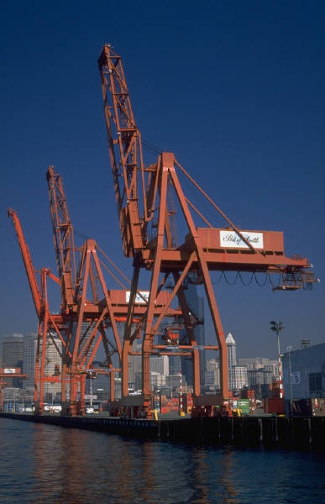
Terminology Worksheet
Name: ___________________________Period:______ Date: ____________
Define the following terms and use them in context, writing complete sentences.
- Port Pollution
  - Bunker fuel
  - Floating booms
  - Environmental Protection Agency
  - Liquefied natural gas
  - Volatile organic compounds
  - Particulate matter
  - Nitrogen oxides
  - Mitigation
  - Noise barriers
  - Sediment
  - Water skimmers
- Green Ships
  - Ecosystem
  - Renewable technologies
  - Sulfur dioxide
  - Hybrid engine
  - Biofuels
  - Hydraulic fluid
  - Optimization
  - Bulbous bow
  - Ballast
- Port Logistics
  - Intermodal freight
  - Automation
  - Trans-shipment
  - Gantries
  - throughput
  - Bulk cargo
  - Commodities
  - Longshoremen
  - Container yard
  - Fork lift
- Containerization
  - Modular
  - Standardization
  - Domestic
  - Mechanical Handling Equipment
  - Supply chain management (SCM)
  - Twenty foot equivalent unit
  - Radio frequency identification (RFID)
  - Electromagnetic field
  - Comprehensive
  - Trade-offs

